Record No: 0679
EDMUND GRAY STUART TRUELL (Edmund)

2nd son of Rev William Henry Augustus Truell by his wife Lady Cornelia, (nee Stuart).

Birth: 14 Aug 1878, Chettle, Dorset.
Marriage: 14 Aug 1912, Wicklow Church, Vere Frances de Merlie Bellingham, dau of Bellingham Arthur Somerville and Margaret Hall (nee Clinch)
Death: 3 May 1950, Onslow, Wimborne, Dorset
Burial: Broadstone cemetery, near Wimborne Dorset

Source: Somerville Index
Further research:

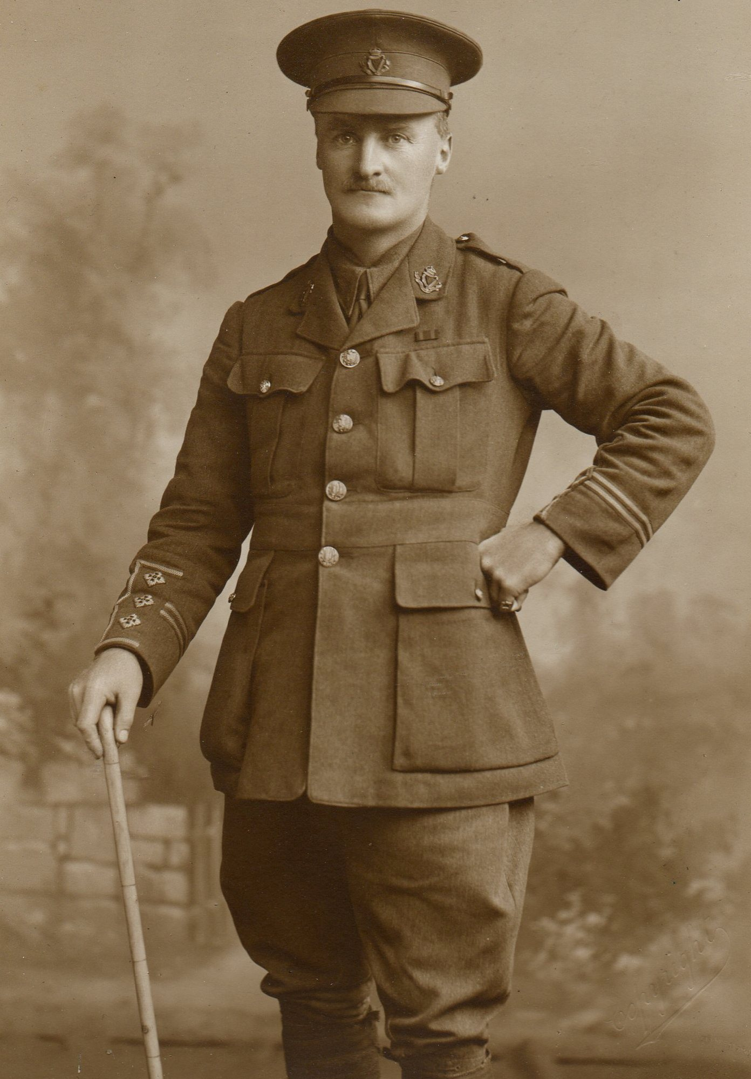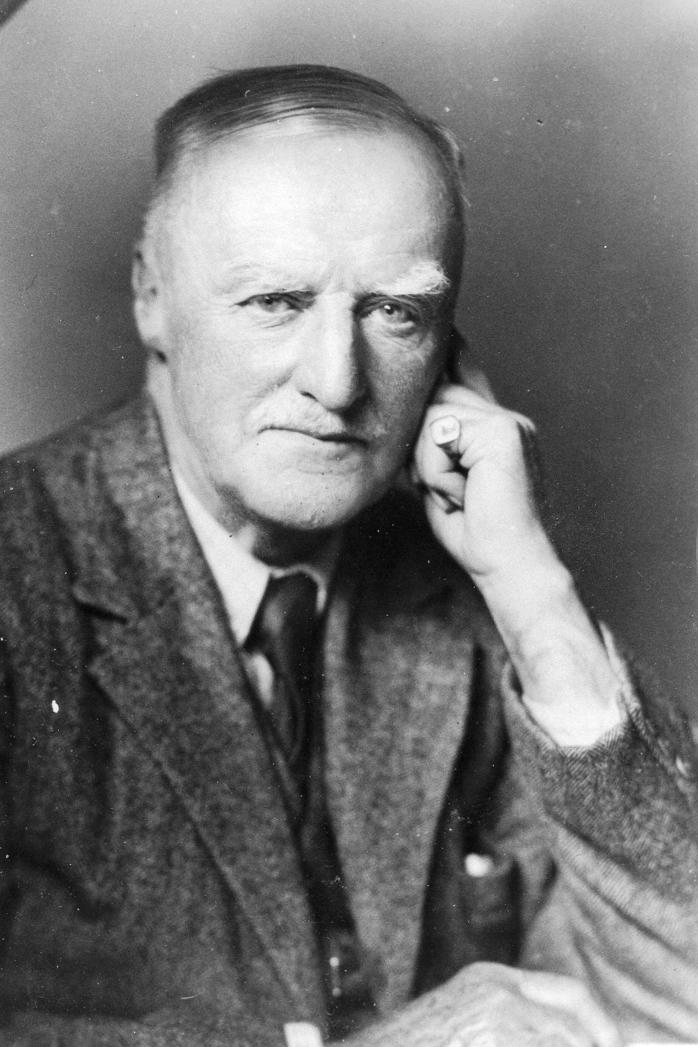

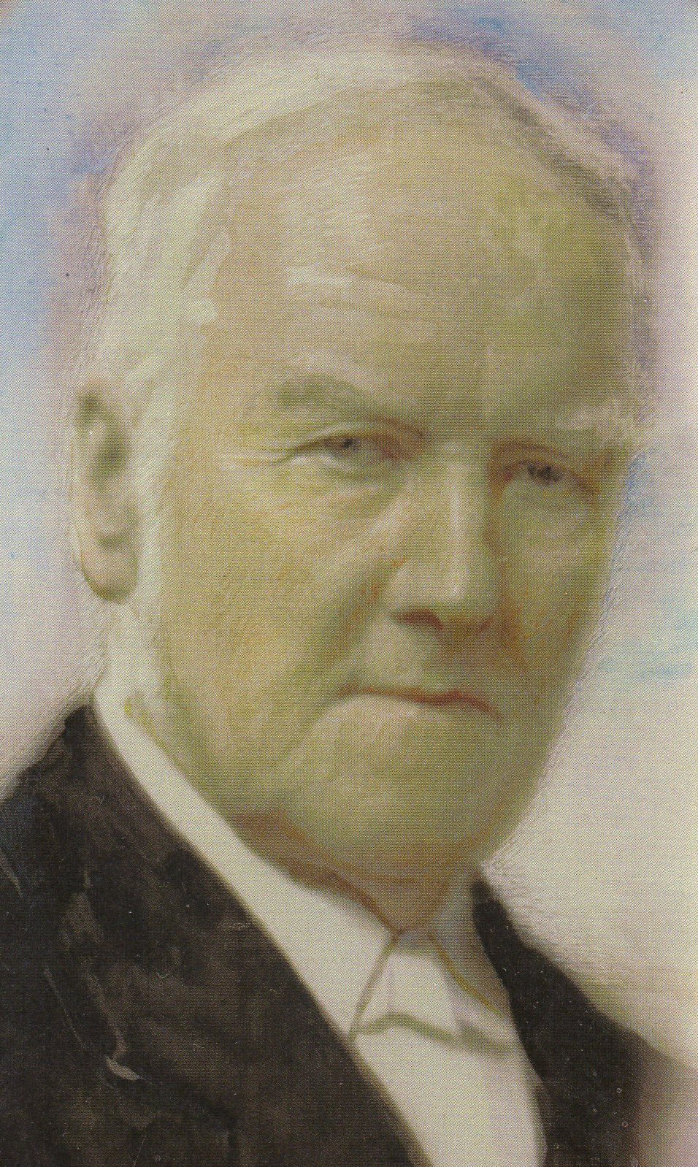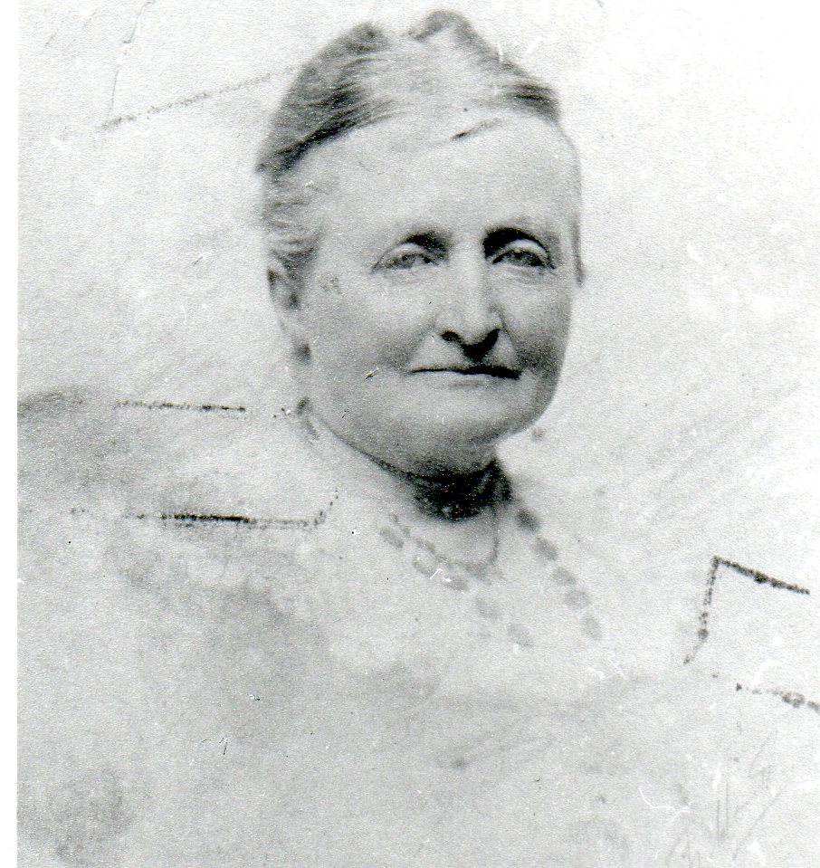

Top Left: EGSTruell, Great War
Top Right: Rev W. H.A. Truell
Middle Left: EGS Truell, c.1949
Middle Right: Lady Cornelia Truell
(nee Stuart)
Bottom Right: Maj Gen R H Truell

His mother’s brothers were:
Edmund Archibald Stuart, later 15th Earl of Moray (1840-1901)

Francis James Stuart, later 16th
Earl of Moray (1842-1909)

Morton Gray Stuart, later 17th
Earl of Moray (1855-1930)

His father was the younger brother of Maj General Robert Holt Truell.

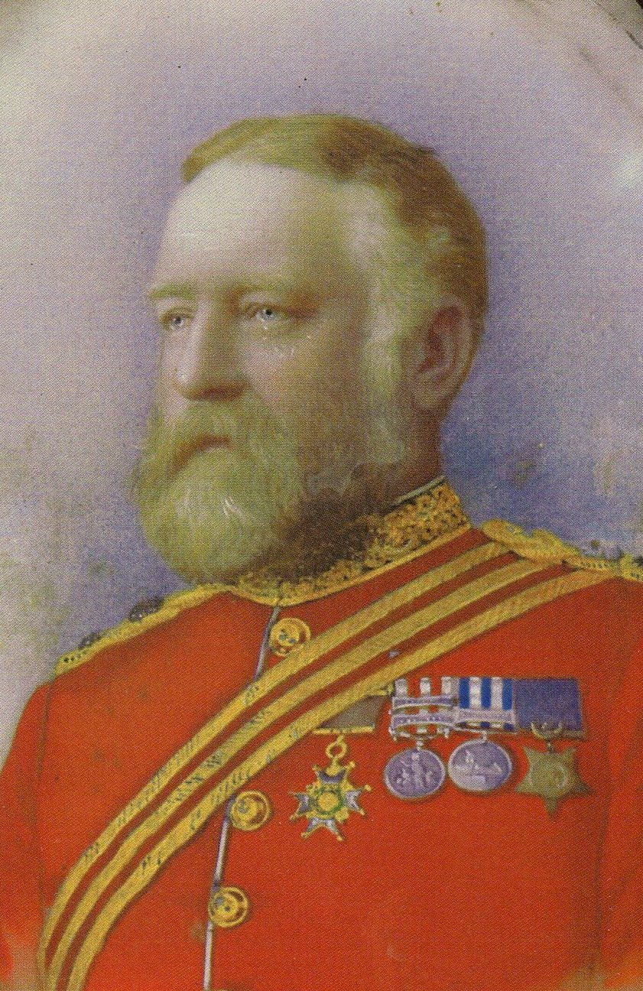

TRUELL, Maj.-Gen. Robert Holt
CB 1885
Born East Stoke, Somerset, 30 Sept. 1837; o s of Rev. William Truell, Clomenenon, Co. Wicklow, Ireland; m 1st, 1884, Elizabeth, d of Rev. Canon Onslow; 2nd, 1890, Harriet, d of G. Churchill, Aldershott Park, Fordingbridge; died 4 Sept. 1900
JP Dorset

Education
Cheltenham Coll

Career
Joined 53rd Regiment at Calcutta, 1856; served throughout Indian Mutiny, including relief of Lucknow; capture of Lucknow; Transgogra Campaign, 1857–59; Canada Fenian raid, 1866; Egypt, 1882; Suakim, 1885; staff-officer India and Canada (despatches, medals for India, Canada, and Egypt, Khedive’s star and CB); retired from command of 53rd, and promoted Hon. Maj.-Gen., Aug. 1885. Decorated for Suakim expedition, 1885

Recreations
Cricket, shooting, golf, tennis

Club
United Service

Address
Onslow, Wimborne, Dorset
‘TRUELL, Maj.-Gen. Robert Holt’, Who Was Who, A & C Black, 1920–2008; online edn, Oxford University Press, Dec 2007 [http://www.ukwhoswho.com/view/article/oupww/whowaswho/U191680, accessed 26 July 2011]

Note for David Gilmour:

I suggest that George Truell’s note about his father and the letter from Ray to Charles Riley should be included here. I have no information to add. I do however think it would be worth including something on Clonmannon and the reason why Edmund didn’t inherit Clonmannon on the death of his bachelor brother Bertie as one would expect. I was always told he didn’t wish to live in Ireland and opted to take Onslow instead. I personally witnessed Michael Truell, many years later, being upset that as the eldest Truell of the next generation he had not inherited /would not inherit Clonmannon. WHS Truell was a very different character to his brothers; I remember him well.

Finally, as this is a profile attached to the Somerville index or pedigree, there should be a reference to the Truell indexx or pedigree for further information. The same for Vere..

